A Title for a Full Paper Title Case (Helvetica or Arial 14pt Bold)

Presenting Author and other Authors (Times or Times Roman 11 pt)
School of Solar Engineering, Manufacturing Engineering
Rio de Janeiro University of Technology
PO Box 2434, Rio de Janeiro 21945-970 RJ
BRAZIL
E-mail: P.Author@UFRJ.edu.br
Web-page: www.insitute.xy

Abstract (in Times or Times Roman 11 pt italics justified)
This abstract in Times New Roman 11 pt is justified. The main document below shows you how to lay out your paper. All you need to do is copy the entire file (max. 8 pages) to your hard disk, print it for reference, overwrite this text with your own and save it as a file with the same name as your abstract, but using x, y and z for the version indicator (instead of 1,2 and 3). You can use either *.doc, *.rtf, or *.pdf. Zip it together with the graphic files (using the same name as for the text, but adding fig1, fig2 etc to the end of the version indicator it) and upload to our server at http://www.rio02.de/participation/upload.html.

Introduction (Times New Roman Bold 11 pt)
If you follow the format of this paper faithfully you will make our job easier and help ensure that all contributions in the final publication look professional and consistent. Please take a minute or two to read through the following instructions before beginning your paper.

Heading Level 2 (Times New Roman 11 pt Bold Title Case )
This text is in Times New Roman 11-point. We hope this template complete with header and footer formats will make it easy to lay out your paper for the proceedings.
When you have completed your abstract, check that you have deleted all instructions and headings in this template. The final paper can then be uploaded into the Abstract/Paper Submission Form as explained in the form and sent to the Congress organizers.

This example paper is supplied to you in Rich Text Format (RTF) or Word 97 format. Older word processors should still be able to read it the RTF format version. Text should be single-spaced.
The paper should be structured into an introduction, main body (arguments, results, discussion, etc) and a concluding section.

Margins and page allowance
Set out your paper on A4 size the same as this, with margins as described in Table 1.

Table 1. Margins to use in this paper

Margin | Size
Inner (gutter) | 25mm
Outer | 25mm
Top and bottom | 25mm

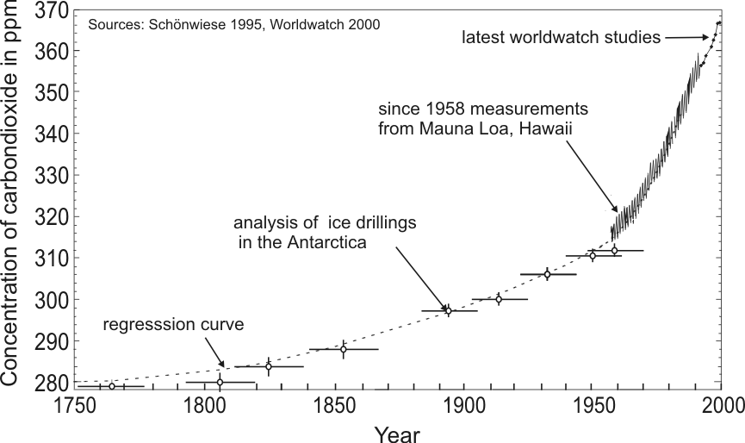
Figure 1. Example of for a Figure for formatting a full paper.

Page numbers should be placed on the outside bottom of each page in the footer margin. Number your pages 1, 2, 3, etc. with the page number suppressed on the first page.
There is a maximum of eight pages for the full paper.

Guidelines for putting graphics in your paper
Graphic objects such as charts, photos and line drawings should be in electronic form and be pasted into the document and additionally saved on a separate file, to be submitted together with the paper in a .zip file. Vector Graphics are preferred. For bitmaps, use either JPEG or GIF format graphic files as they are more compact than bitmaps like BMP. Number your figures Figure 1., Figure 2., etc with a centralized short caption under each in 11-point Times New Roman to distinguish it from the main text. Zip it together with the text file (using the same name as for the text file, but adding fig1, fig2 etc. to the end of the version indicator it) and upload to our server at http://www.rio02.de/participation/upload.html (e.g. upload of Auth_P_12_19_1_x.zip containing Auth_P_12_19_1_x.rtf, Auth_P_12_19_1_xfig1.gif and Auth_P_12_19_1_xfig2.gif).

Tables
Tables should be labeled Table 1., Table 2., etc at the top of each table.

Units
It is strongly preferred that units be in the S.I. system (Système International).

Footers and headers
The header in Arial 10-point italics should state the paper title on the left (abbreviated if necessary), and last name of first author of the paper, suppressed on the title page.

The footer in Arial 9-point italics should follow the format shown below.

Equations
Mathematical equations should be laid out wherever possible using an equation editor and be numbered consecutively as in this example (11 pt Times New Roman):

I_{j} = S_{j} + σ_{j} (3)

The equation should be separated by a blank line above and below, and the equation number should be right-aligned on the right margin

ACKNOWLEDGMENTS
List here, where applicable, funding sources for the work described and contributors to its intellectual content.

REFERENCES
The Harvard system should be used for all referencing. References should be presented in the body of the text as follows: Barker (1992) or (Barker, 1992) for one author, (Jones & Smith, 1998) for two, and Feugard et al (1994) for multiple authors. They should be listed in alphabetical order according to the example formats in Section 4. Where the original author’s words are repeated verbatim, references should include the page number for the quote, e.g., ‘… this is the quote’ (Black, 1996: 38). Quotes that are less than three lines should be enclosed in quotation marks

References Placed at the End of the Paper
The general format for references is as follows:

Author’s surname, initials. (Year of Publication), Title in Italics, Name of Publisher, Place of Publication. (11pt Times New Roman)

Some specific examples of reference styles for different types of publications are given in the rest of this section.

1. Example for book references:
Smith, N.J. and Jones, M. (1979), A Companion Guide to Good Authorship, Social Work Press, Sydney.

2. Example of referencing for a chapter or article within a book compiled or edited by others:
Where the reference refers to a paper or article in a book, journal or conference proceedings, page numbers for that paper or article are required. Acknowledgement needs to be given to editing authors for books or conference proceedings.
Morris, J.S. (1986), The Art of the Review, in Warren, E.G., “Innovations in Editing”, Bromley Press, Sydney, pp. 8-12.

3. Example for journal article references:
For articles in journals, the article name is italicised and the journal name is in normal text. The journal name is followed by its volume number, then its issue number in brackets, a comma and then the page numbers for the article.
Wright, O.R. (1969), Summary of Research on the Selection Interview Since 1964, Personal Psychology, 22 (2), 391-413.
Feugard D.C., Abner R.. Smith P. and Wayland D. (1994). Modelling daylight illuminance, J. Climate Appl. Meterol. 23-109.

4. Example for Conference Proceedings:
Vlacic, L., Mills, D. and Lowe, I. (1996), Integrated Resource Planning: A Multicriteria-Based Decision Model, in Gertler, J.J., and Peshkin, M. (Eds) Preprints of the 13th World Conference: International Federation of Automatic Control, San Francisco, June 30 – July 5, 1996, pp. 267-272.

Unpublished Paper
Lewis F.M. and Abbow C. M. (l976). Pyrogas from biomass. Paper presented to Conference on Capturing the Sun Through Bioconversions, Washington, D.C.

